NAME-ANIKET NARALE

1. Install NodeJs
2. Install Angular CLI
3. Install Visual Studio Code Editor
4. Create Default Structure by using angular-cli commands.

Reference:

- <https://nodejs.org/en/>

- <https://cli.angular.io/>

- <https://code.visualstudio.com/>

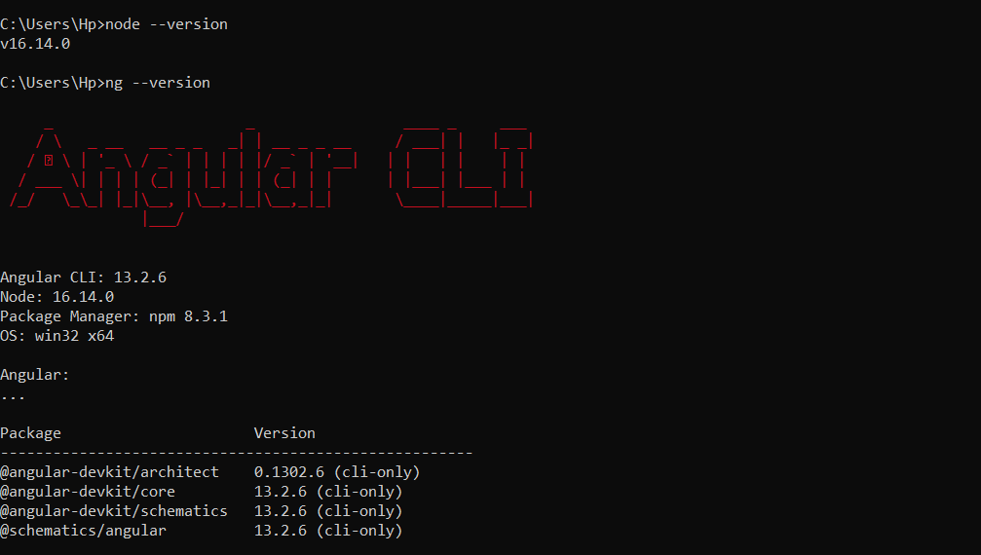

# 2. Overview Of Assignment

Create web app which help to manage and maintain restaurant chain including,

* Module

-Admin

-Restaurant ( create / Edit / Delete )

-Menu ( create / Edit / Delete )

-Menu Assignment To Restaurant

-Restaurant Owner

-User ( End User )

# 3.Steps

1. Create application Structure by using angular-cli
2. Create component

* Admin
* Menu
* Restaurant
* User

1. Implement routing
2. Admin Module

* Create Dashboard containing two tiles.

Menu

Restaurant

1. Menu Module

* Menu List Table containing ( Add / Edit / Delete)
* Only admin can add, edit and delete menu
* Restaurant owner can view menu.
* Create one section to assign menu to restaurant.

1. Restaurant Module

* Restaurant List Table containing ( Add / Edit / Delete)
* Only admin can add, edit and delete Restaurant
* Restaurant owner can view menu.

1. User will place order by using dashboard.

* Display restaurant List
* User will choose restaurant
* Display menu according as per selection of restaurant
* Select Menu
* Place the orders
* Confirmation Page ( If success, if fails then show message according )

**Project –**

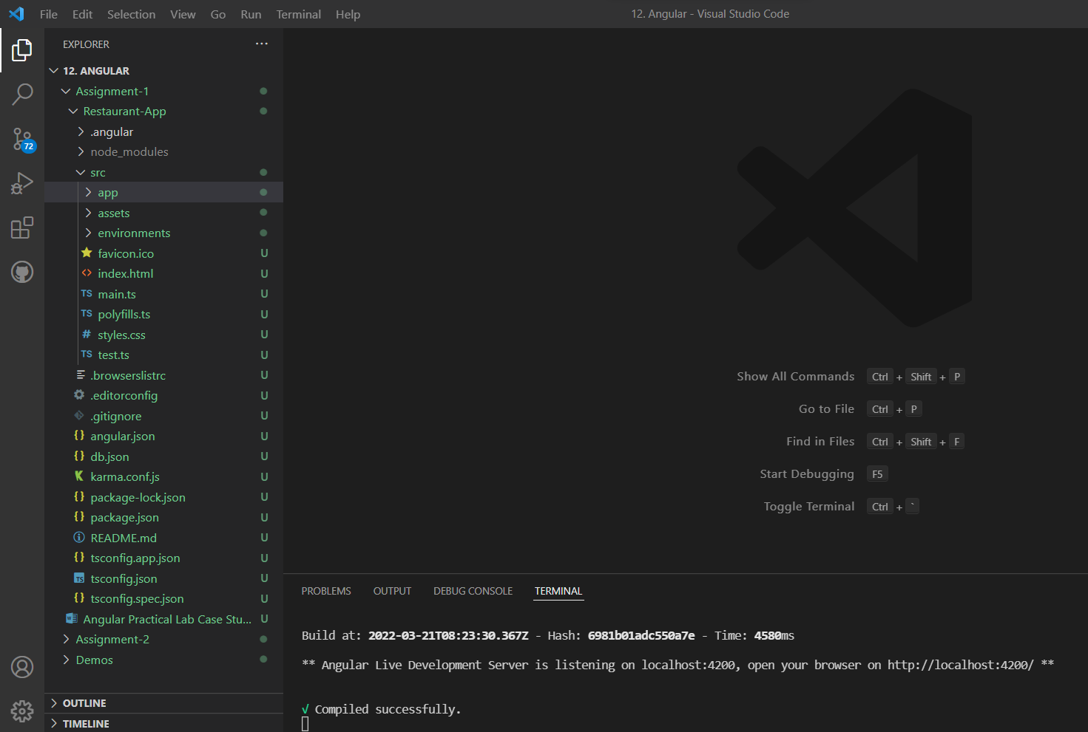

Add Restaurant –

